Quality of Training & Outcomes Process

JC Training and Consultancy follow The Kirkpatrick Model that takes into account all types of training and can be applied to both formal and informal training.
The model consists of four levels of evaluation:
- Level 1 – Reaction
- Level 2 – Learning
- Level 3 – Behaviour
- Level 4 – Results

1. Reaction – Where the reaction of learners and employers is measured
Level 1 – Where the reaction of the learners is measured; what they thought and felt about the training. Did learners like and enjoy the training? Did they consider the training relevant? Was it a good use of their time? Did they like the venue, style and timing of the training? What was the level of participation? What level of effort was required to make the most of the material?
We are ultimately looking for learner satisfaction. What we are looking for is a positive reaction when people describe their training experience to you. To achieve this, we obtain quarterly satisfaction surveys from all learners and employers to gauge their satisfaction this is quantified, analysed and reported to SMT as well as learners and employers.
The information and feedback gathered is used to help improve services provided and to measure the impact of policy and processes introduced to improve the overall satisfaction and compliance of JC Training and Consultancy’s service.
We benchmark overall satisfaction at 90%, as set to ensure only the highest possible service is delivered at all times to achieve consistency and trust in the training we provide.

2. Learning – Where knowledge from before to after the learning experience is measured and progression is identified
Level 2 – Where the increase in knowledge or intellectual capability from before to after the learning experience is measured. Did the learner learn what was intended to be taught? Did the learner experience what was intended for them to experience? What is the extent of advancement in performance or change in the learner after the training?
Typically, learning is assessed using a pre-test/post-test method. Learners can be given a written exam to assess knowledge or an on-the-job practical evaluation.

To measure learning JC Training and Consultancy use a range of measurements including Progression Tracking where every learner’s progression is tracked monthly. This is further measured with RAG rating model that from RAG Rating Calculations that are based upon the expectation of establishing learning patterns where quantative calculations determine expected progression and potential estabilishment of learning patterns and achievement recognised at the earliest possible time.
Progression Calculation:
Progression Target = T / 100 x L
Where:
Total Length of Programme = T
Length of Programme = L
A Green RAG rating indicators 100% achivement for progression, target achievement, attendance and timely achievement.
An Amber RAG rating is indicator on a potentional for the establisment of learning patterns based on progress being more than 2 months behind, missed visits, not all targets being achieved and potential for untimely achivement.
A Red RAG rating is based on the continous of a learning pattern, therefore an establish learning pattern where a learner is more than 3 months behind target, not attending visits, not achieving targets and untimley achievement is likely.
Learning patterns such as missing visits and not achieving targets are pre-cursors that identify future issues around timely completions and lack of progression and therefore a lack of learning, therefore we use this quantitive data to not only monitor individuals but tutor performance including isolation to locations and qualifications.
Our benchmarking calculations are based on internal and external factors such as ESFA benchmark, funding requirements, caseload total and expected tutor performance.

Each caseload and combined caseloads have the following benchmarks:
- Visits on Track: 85%
- Progression on Target: 90% (with max amber of 5% and maximum red of 5%)
- Functional Skills first time pass: 90%

These benchmarks set are essential to meet the Overall Achievement and Overall timely achievement benchmarks set by the ESFA on an annual basis. Resulting in the following achievements for 2017/18:
- Apprenticeship achievement rates for 2017/18 is 77.78% overall and timely achievement
- Education & Training rates (AEB) is 100% overall achievement and 92.31% timely
JC Training and Consultancy deliver apprenticeships nationwide across a range of Employed and Associate staff therefore it is vital that all tools are used to evaluate and measure the level of teaching and learning being achieved. In addition to the above quantitive measurements, qualitative measures are taken to report and record delivery levels including:
- Learner Document Audits – Measures compliance, accuracy of learner records and identification of development areas.
- Observations of Teaching and Learning - Internal Verifier observation of tutor delivery with reporting and identification of development areas.

3. Behaviour – Where transfer is measured
Level 3 – Where the extent to which the learner has applied the learning and/or changed their behaviour on-the-job, also known as knowledge transfer, is measured. Did the learner put their learning into effect? Were relevant skills and knowledge used? Is the learner able to transfer what they learned to other situations or to other colleagues?
Examples of tools you can use to measure behavioural changes include ongoing assessments, observations and interviews combined with feedback. Self-assessment can also be useful if you have identified a clear criteria and measurement standards.
JC Training and Consultancy implement this element of training evaluation through succession, progression and destination data collection.

4. Results – Where the effects of improved performance is measured
Level 4 – Where the effect of improved performance on the business, organization or environment is measured. Generally, key performance indicators are evaluated and reported on overtime.
As suggested by Jeffery Berk, “the Kirkpatrick model is nice, but without a process to measure these levels it might not be practical”.
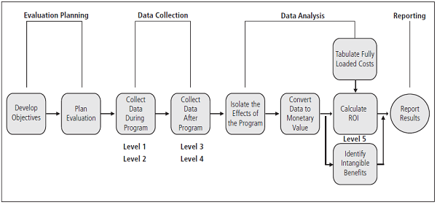
Figure 1. The Phillips ROI Methodology – Source: ©ROI Institute.
Use Learning Analytics and Metrics
Generally, the goal of training is twofold: to improve employee performance through skill development and to see a return on investment (ROI). Data driven learning analytics and reporting helps organizations link training performance to essential business results.
There are several metrics that you can use to evaluate our training initiatives, including:
- Change in performance ratings over time
- Customer/client satisfaction ratings
- Employee engagement
- Employee turnover rates
- Percentage of promotions
- Productivity rates over time
- Employee retention rates

